Angielena Williams
Walden University

Introduction
Welcome new and future early childhood professionals! I have created a beginning of the year classroom set up using best practices to ensure that you are being culturally aware and diverse in your room set up. Each area has an explanation for any teacher and most a visual representation of the arrangement of space or aid used in a particular space. Enjoy!

- At the beginning of the school, the teacher hosts a Meet and Greet, inviting all of the families to come out and visit the classroom with their students. They engage in a classroom scavenger hunt and a simple parent-child activity. The teacher provides the families with a Family Background sheet, an All About Me form, and asks for a copy of a family photo for the classroom. “A ‘caring community of learners’ does not just happen; it is intentionally created, beginning the first day of preschool (or even before with notes and photos sent home, home visits and other connections).” (Copple, Bredekamp, Koralek, and Charner, 2013, p. 41) In doing so, the teacher will be able to identify the home language and make-up, preferred nick names, religious and celebration preferences, food and medicine allergies, amongst other things.
- Using the information gathered the teacher sets up the classroom environment with family photos all around the room, labels in English and other languages to accommodate ELL students and to encourage autonomy in all students to know where things belong.

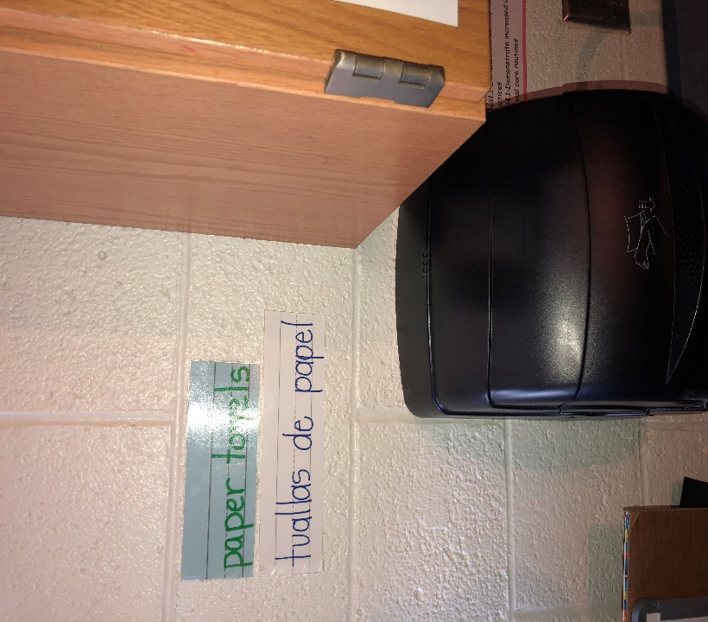
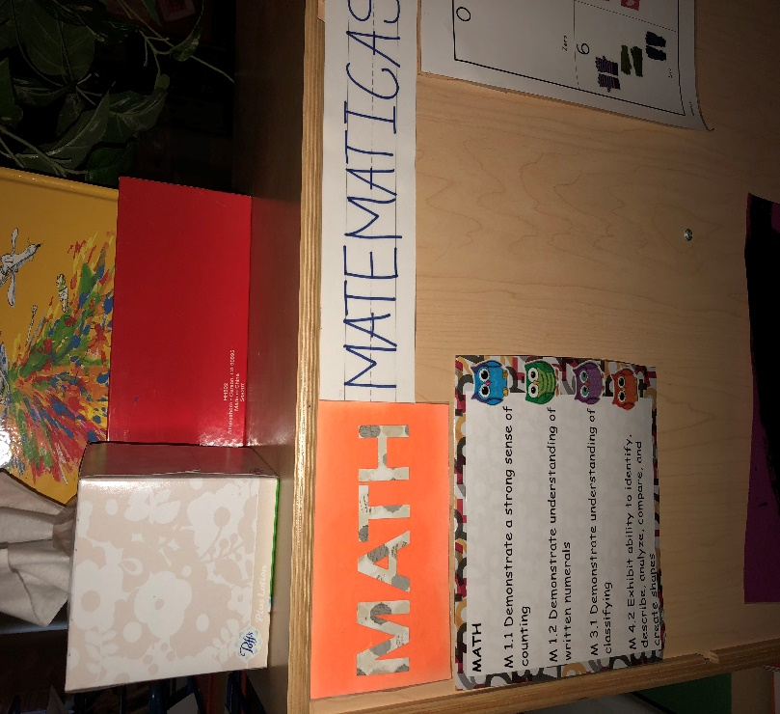

- The teacher also labels each center and adds a visual representation of how many student are allowed in each center, along with Velcro dots for the students to be able to add their individual pictures, helping others to recognize if a enter is full. The center includes a description using the Indiana Foundations for Children Birth- Five years, explaining to any adult present, what that center encourages. Each center has more than three choices for students, including materials to write with and books relevant to the center.
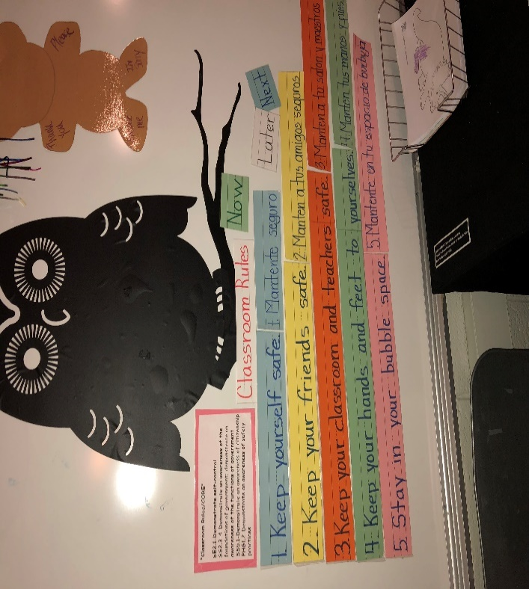
- Classroom rules are posted in more than one language, relevant to the students and were created as a class community. “Rather than reacting to children’s violations of rules with harsh discipline, teachers can reason together with children and help them think about the consequences of behavior.” (p. 43-44) This provides safe boundaries and limits for the children and the words to use when a conflict arises.

- Spaces for children’s individual materials are labeled with their name and/or a picture. Student’s are provided individual learning tubs that have materials specific to their individual learning needs.

- Students are encouraged to interact together in whole, small and independent activities.
- Books in the library area include real and drawn photos depicting a variety of ethnicities, community helpers, emotions, and topics specific to the class community. Teachers also invite parents and community members to be a Mystery Reader to the class and to share specific cultural specialties.
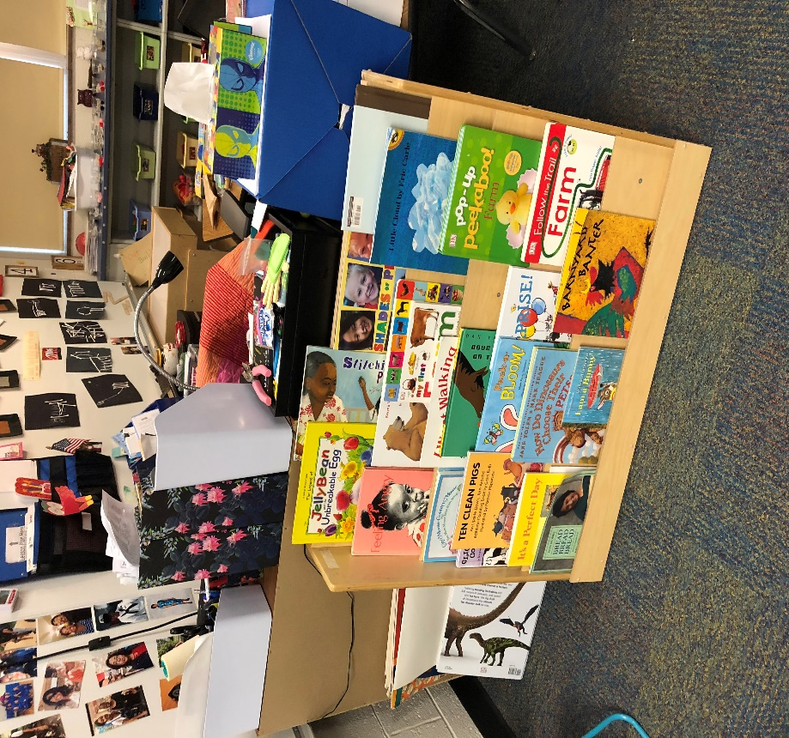

- In each center, the whole group area, in the bathroom and on the door out of the classroom, are visual pictures that support the use of Positive Behavior Interventions and Supports (PBIS), describing in pictures the expectations.
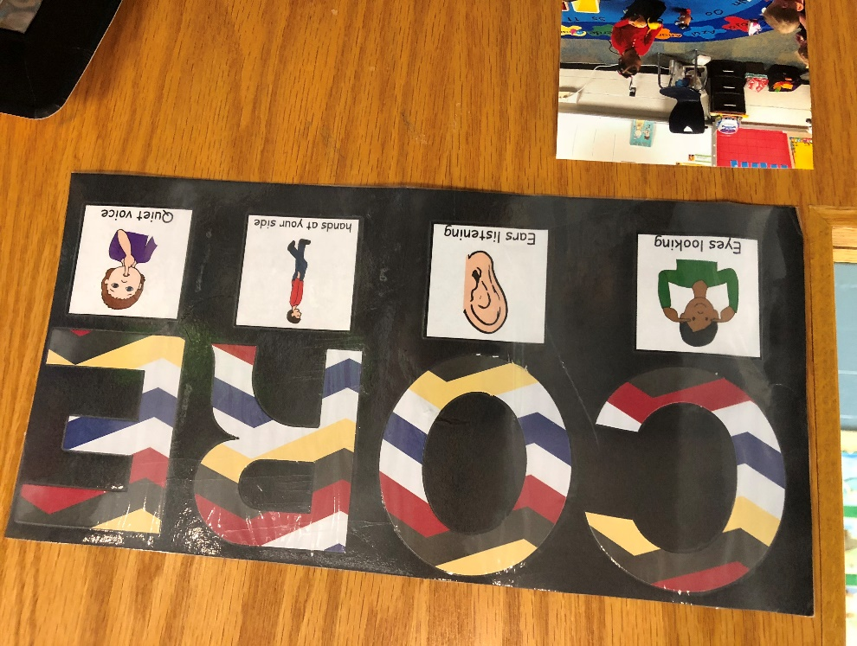

- Children are encouraged to use their words, following what teachers model. They are also encouraged to play with others but have the choice to be alone. There is a quiet place in the classroom for student’s to be by themselves.
- Having had students that required extra supervision, needing more specific visuals and environmental cues, teachers have placed stop signs in areas to notify students to stop before any other action or to not touch. Teachers have also placed a chime on the door to notify them of anyone entering or exiting the classroom.
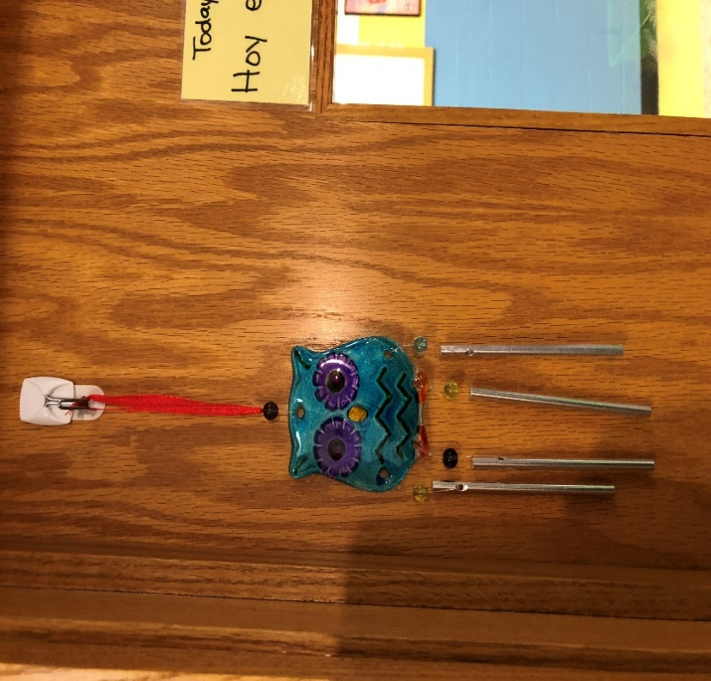
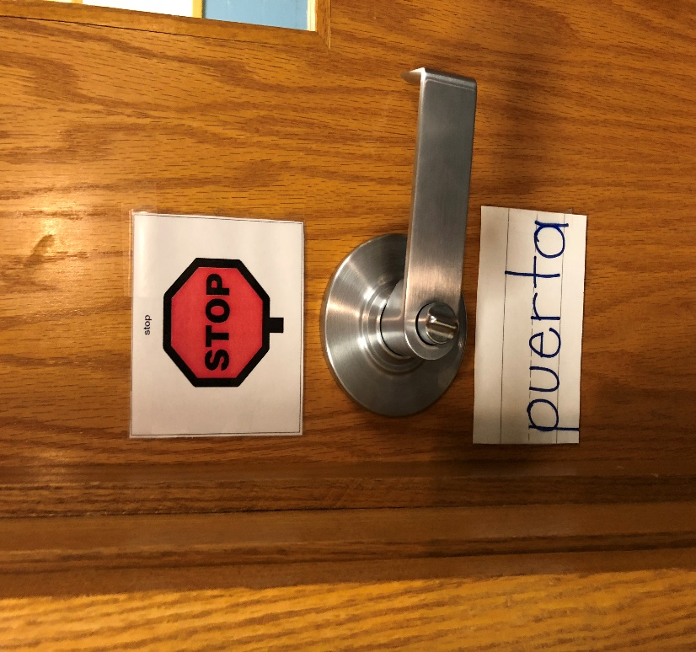

Summary
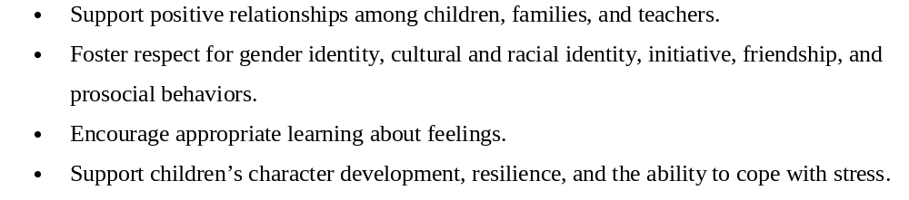
Within this assessment artifact, I have presented specific examples of how to:

References
Copple, C., Bredekamp, S., Koralek, D., and Charner, K. (2013). Developmentally Appropriate Practice: Focus on Preschoolers. NAEYC; Washington, D.C.

